CS 330 Design Decisions
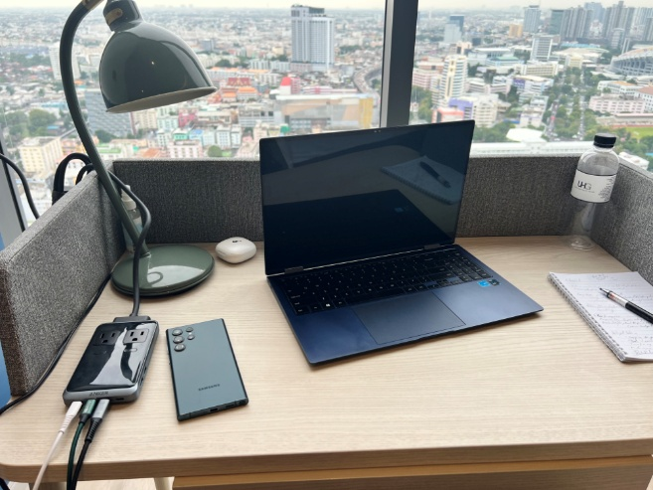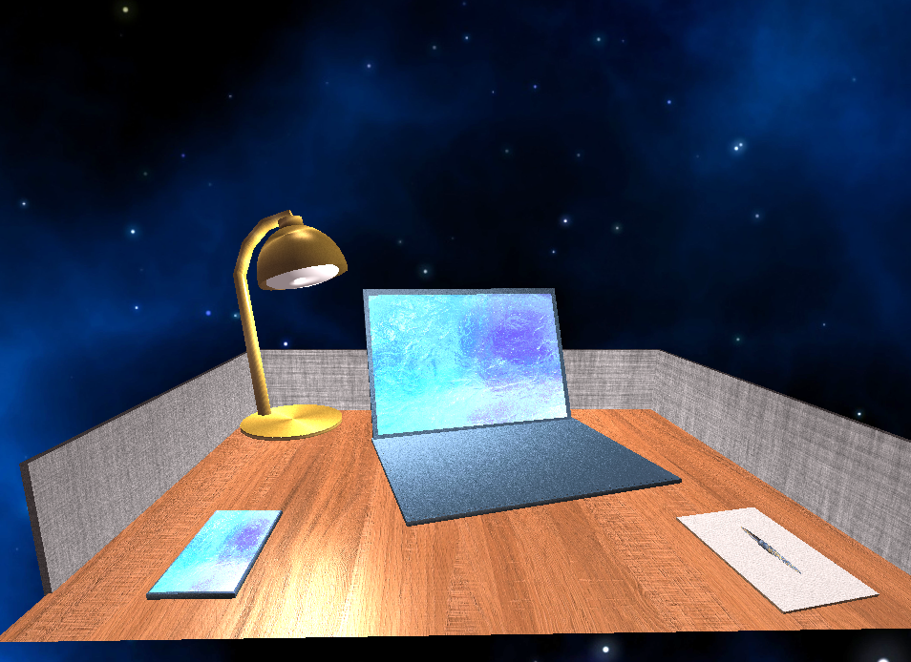
For this project I took an approach of simplifying the most impactful objects in the scene. As the scene is originally, it is washed with strong daylight and doesn’t leave much room for additional vibrance and focus on the objects. By using a nighttime scene, I can make use of the desk lamp as the main light and focus closer on the desk and it’s main items. When designing scenes for any application, one of the main draws is creativity and relatability. I know a lot of night owls spend time with a setup like this one and I’m no exception. To actually build the scene I started by replicating the desk ignoring the space beneath. Once the desk is made, everything else will be made to fit on the desk, so it’s the perfect starting point. My most complicated design was the lamp because it has the most curvature so it was made last and given the most detail of any item. Everything else was depicted using layered boxes and tinkering with the angles to give the scene some life and the textures take care of the real detail in the scene.
To navigate the scene, you can use the well-known gamers default WSAD keys to move forward, backward, left, and right. You can ascend and descend using Q and E respectively. The default scroll speed is a bit slow, but it can be decreased further by scrolling down with the mouse or mousepad. It can be increased as high as 5 times the default by scrolling up. In addition to navigating 3D space, you can switch the perspective to orthographic or a 2D view of the scene with the O key. To switch back to the 3D or perspective view, press the P key.
The code used to create the objects in my scene required a lot of re-adjusting as I worked on the scene. It could have be refactored using mathematical calculations to place objects within the scene relative to another objects location. The objects themselves could have been refactored into a multi-component single object that fixes each rendered element to it’s relative location to create the whole object as well. This would have made it possible to further modularize the code used to create the scene. The most reusable code I created was the code used to modify the speed of the camera. I added a sensitivity element and modified the existing functions by creating a function to capture the mouse scroll and utilize that along with the key input to move the camera as I needed throughout the scene. The modularized function allows one sensitivity setting to be used and changed by a separate function that is then used in conjunction with the function that responds to key input.

